W10 PRACTICE
DOM & UI EVENT

 At the end of this practice, you can
- Navigate on DOM (parent, sibling, children…)
- Find HTML elements (by id, by class name, by CSS selector)

- Change the content of an HTML element
- Change the style (CSS) of an HTML element
- React to HTML DOM events (ex a mouse click)

- Add and delete HTML nodes to the DOM

 Get ready before this practice!
- Read the following documents to understand JS syntax:
https://www.w3schools.com/js/js_htmldom.asp

 How to submit this practice?
- Once finished, push your code to GITHUB
- Join the URL of your GITHUB repository on LMS

EXERCISE 1 - MANAGE ITEMS
For this exercise you will start with a START CODE (HTML, CSS, JS):

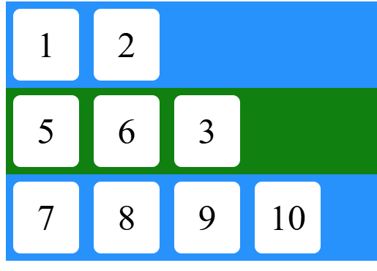
Start code

Q1 – How does the JS file is linked to the HTML file?

Q2 – Write the code in the JS file to move the item 3 to the second container
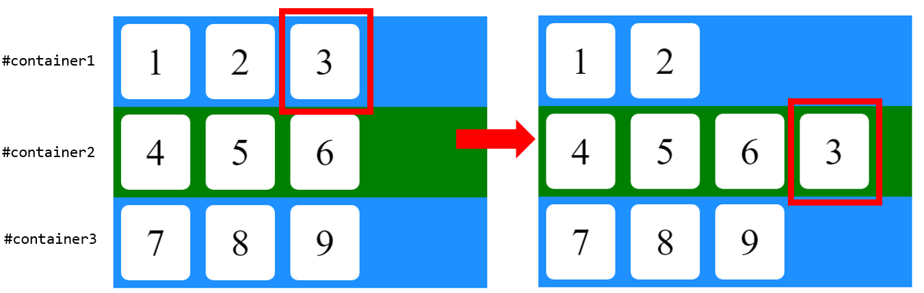

Note: In the DOM, an element can only have one parent at a time. When you append it to a new container, the browser automatically detaches it from its previous parent.

Q3 – Write the code in the JS file to remove item 4

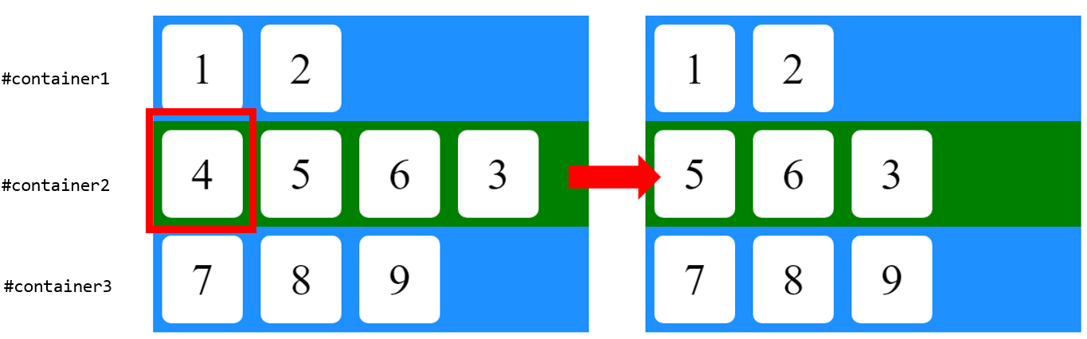

Q4 – Write the code in the JS file to create an item 10 and to add it to the container 3

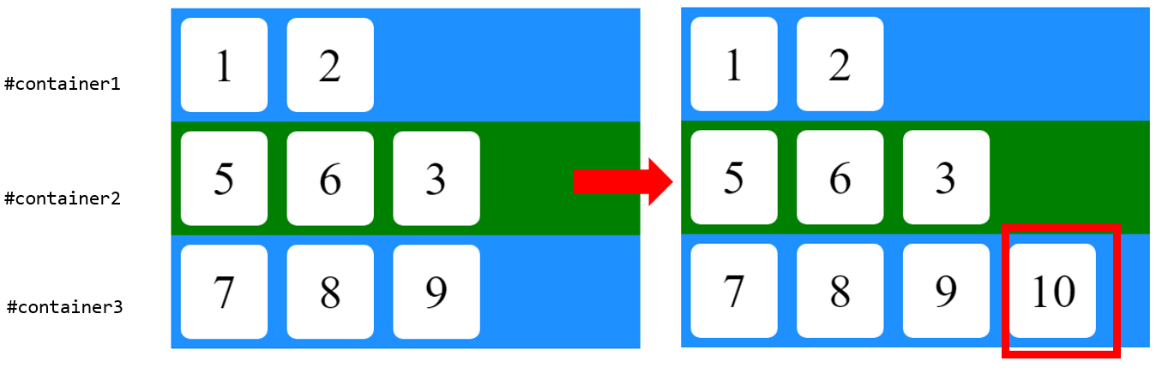

Q5 – Write the code in the JS file to display all items located in a blue container in red text

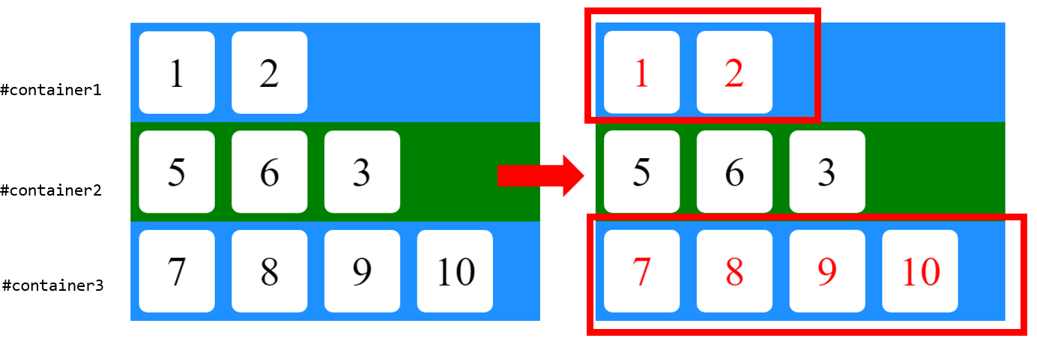

EXERCISE 2 – RANDOM COLOR
For this exercise you will start with a START CODE (HTML, CSS, JS).

When clicking on the RANDOM COLOR button:
- Generate a random color
- Set the body background color with this color
- Set the color label with the value of this color

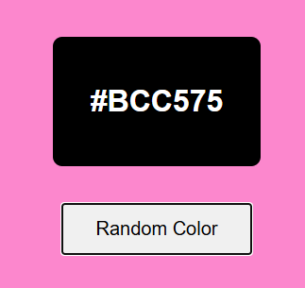

Note: we already provide the function to generate a random color:

// Generate a random hexadecimal color
function getRandomHexColor() {
const letters = '0123456789ABCDEF';
let color = '#';
for (let i = 0; i < 6; i++) {
color += letters[Math.floor(Math.random() * 16)];
}
return color;
}

EXERCISE 3 – CREATE & REMOVE CARDS
For this exercise you will start with a START CODE (HTML, CSS, JS).

Q1 - When clicking on the CREATE CARD button:
- Create a new card as specified bellow
- Add this new card to the container DIV

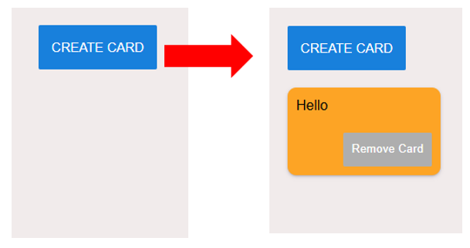

- A card is composed of the following HTML elements.
You need to set the element CSS class as specified!

<div class="card">
<p>Description</p>
<div class="card-footer">
<button>Remove Card</button>
</div>
</div>

- The card background color shall be randomly generated.

Note: we already provide the function to get a random color

const COLORS = ["red", "blue", "green", …]

// Get a random color among the list of available colors
function randomColor() {
const randomIndex = Math.floor(Math.random() * COLORS.length);
return COLORS[randomIndex];
}

Q2 - When clicking on the REMOVE CARD button, the related card shall be removed

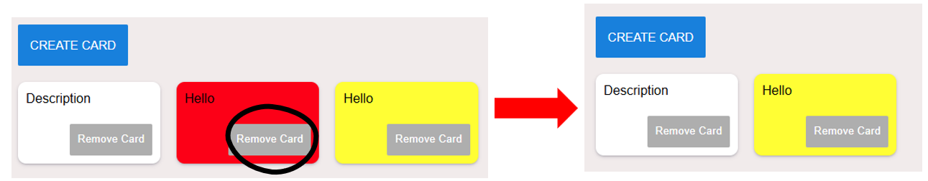

EXERCISE 3 – CADT GAME
For this exercise you will start with a START CODE (HTML, CSS, JS).

In this game, the player has 3 chances to find a secret code.
The game shall work as show bellow:
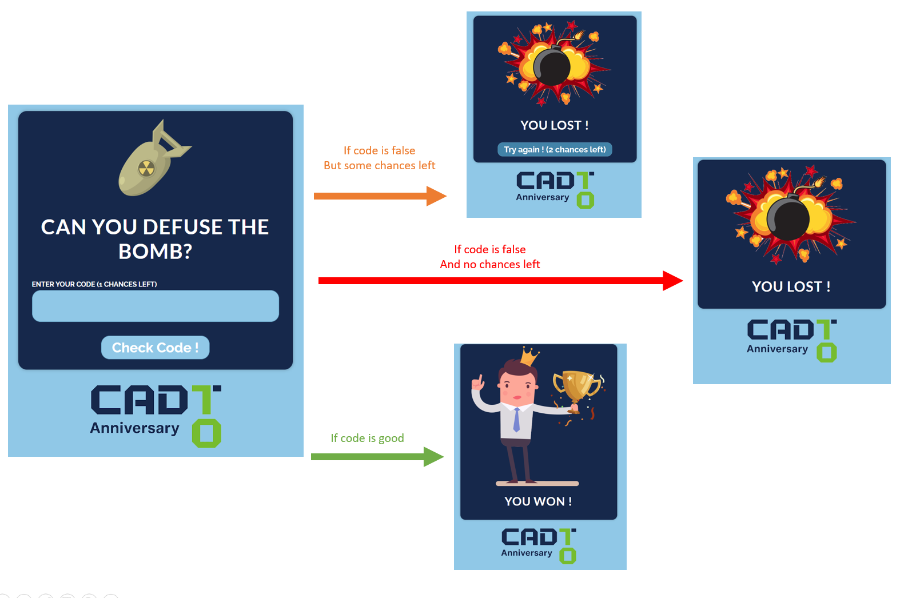
Here are the steps to guide you (if you need):

STEP 1: First when we click on the button Check code, display the LOST view
- Look at the HTML file: we have 3 views (PASSWORD, WON AND LOST view)
- Only the PASSWORD view is visible now, the 2 other views are INVISIBLE (display: none)
- So: what you need to do is to display only the LOST view when we click on the button!

Note: we already provide the 2 bellow functions to show or hide a given element:

// Hide a given element
function hide(element) {
element.style.display = "none";
}

// Display a given element
function show(element) {
element.style.display = "block";
}

STEP 2: Now it time to get the value on the input text and compare it with the secret code

- If the input text is equal to the secret, go to the WIN view
- Otherwise go to the LOST view

Note: to get the value of an input, you can use the value property:
const passwordEntered = passwordInput.value;

STEP 3: Now it time to manage the number of chances

- You can create a variable chanceRemaining which is 3 when we start
- Then you can decrement this variable is the player

- Then you need to update the LOST view

  - If no chance left you need to HIDE the button to try again
  - If any chance left you nee to SHOW the button to try again

- You also need to update the text of the button with the number of chances left
- Finally, you need to be able to come back to the game when clicking on this button

STEP 4 (BONUS)

- We want to store the number of remaining chances and if the player has won, using the local storage
- The goal is to avoid any player who has lost to try the game again

You goal is to learn how to use the local storage and try to store/get those 2 values from the local storage!

EXERCISE 5 - MANAGE TASKS

During this exercise you will create a small app to add and filter tasks

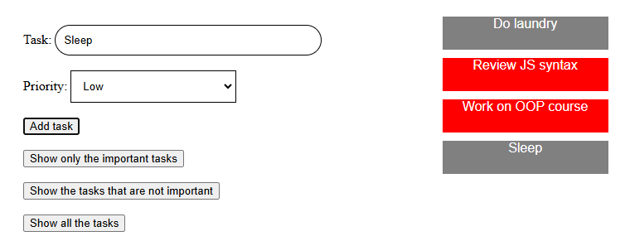

- Tasks can be of high priority (in RED) or low priority (in GREY)
- The list of tasks is stored in a list of objects.
- Each task has a description (string) and a priority (int)
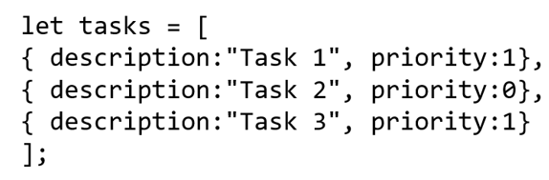

STEP 1
Your first challenge is to display all tasks on DOM, from a provided list of tasks.

- Complete the function displayTasks(tasks) to build DOM elements for each given task.

Specifications:
- Tasks of priority 0 in GREY
- Tasks of priority 1 in RED

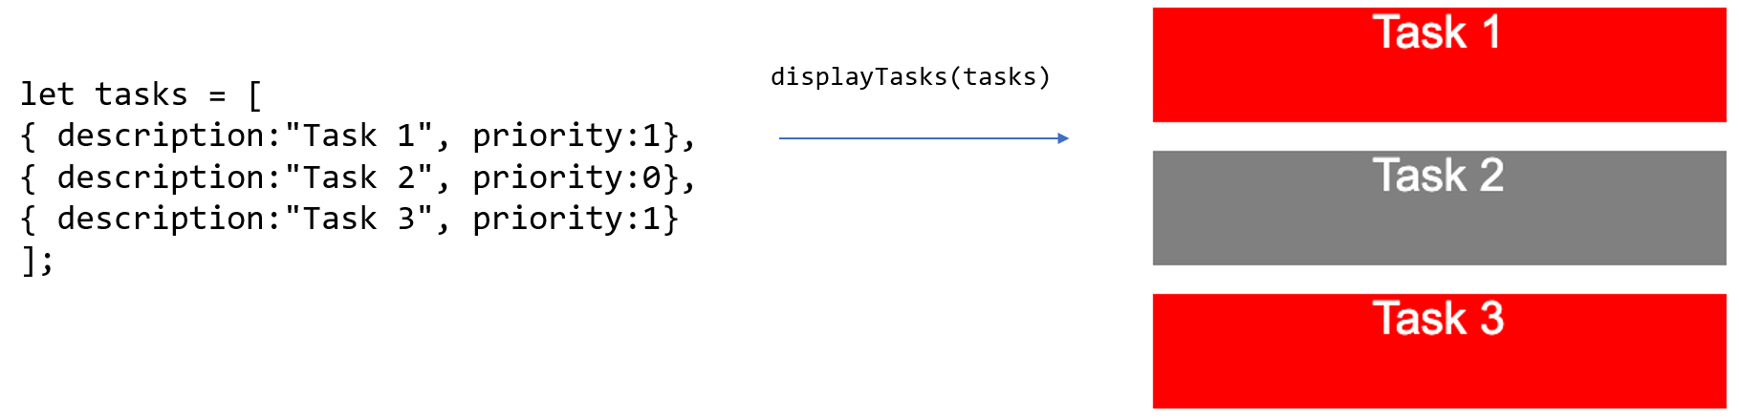

STEP 2
Your second challenge is to add a new task when the user clicks on Add task button.

To perform this challenge:

- Get the input values after a click on add button

- Create a new task and add it to the list

- Update the DOM by calling the displayTasks function
Warning: your need to remove the DOM element related to the old tasks!

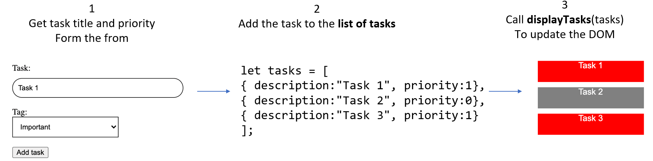

STEP 3
Finally, the challenge consists in adding 3 buttons to filters the tasks

- A button to display only the important tasks (priority = 1)
- A button to display only the not important tasks (priority = 0)
- A button to display all tasks

To perform the challenge, you need to follow the following steps:
- Upon click on one of the 3 buttons, compute the list of tasks to display
- Call the function displayTasks to display this list

